Chapter 6 External Memory 184
6.1 Magnetic Disk 185
6.2 RAID 194
6.3 Optical Memory 203
6.4 Magnetic Tape 210
6.5 Recommended Reading and Web Sites 212
6.6 Key Terms,Review Questions,and Problems 214

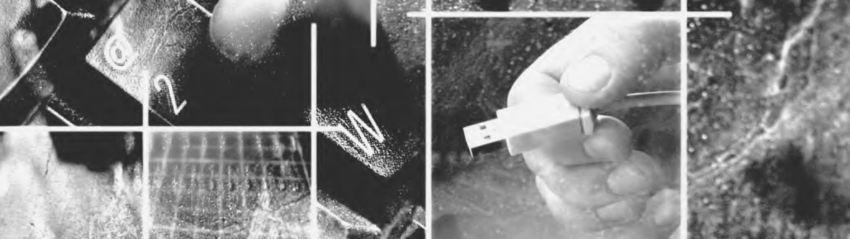
CHAPTER
E
XTERNAL
M
EMORY
6.1
Magnetic Disk
Magnetic Read and Write Mechanisms
Data Organization and Formatting
Physical Characteristics
Disk Performance Parameters
6.2
Raid
RAID Level 0
RAID Level 1
RAID Level 2
RAID Level 3
RAID Level 4
RAID Level 5
RAID Level 6
6.3
Optical Memory
Compact Disk
Digital Versatile Disk
High-Definition Optical Disks
6.4
Magnetic Tape
6.5
Recommended Reading and Web Sites
6.6
Key Terms,Review Questions,and Problems
184

 | KEY POINTS
◆ | Magnetic disks remain the most important component of external memory. Both removable and fixed, or hard, disks are used in systems ranging from personal computers to mainframes and supercomputers.
◆ | To achieve greater performance and higher availability, servers and larger systems use RAID disk technology. RAID is a family of techniques for using multiple disks as a parallel array of data storage devices, with redundancy built in to compensate for disk failure.
◆ | Optical storage technology has become increasingly important in all types of computer systems. While CD-ROM has been widely used for many years,more recent technologies,such as writable CD and DVD,are becoming increasingly important.
This chapter examines a range of external memory devices and systems.We begin with the most important device,the magnetic disk.Magnetic disks are the foundation of external memory on virtually all computer systems.The next section examines the use of disk arrays to achieve greater performance,looking specifically at the family of systems known as RAID (Redundant Array of Independent Disks).An increasingly important component of many computer systems is external optical memory,and this is examined in the third section.Finally,magnetic tape is described.

6.1 MAGNETIC DISK
A disk is a circular platter constructed of nonmagnetic material,called the substrate, coated with a magnetizable material. Traditionally, the substrate has been an aluminum or aluminum alloy material. More recently, glass substrates have been introduced.The glass substrate has a number of benefits, including the following:
- Improvement in the uniformity of the magnetic film surface to increase disk reliability
- A significant reduction in overall surface defects to help reduce read-write errors
- Ability to support lower fly heights (described subsequently)
- Better stiffness to reduce disk dynamics
- Greater ability to withstand shock and damage

Magnetic Read and Write Mechanisms
Data are recorded on and later retrieved from the disk via a conducting coil named the head;in many systems,there are two heads,a read head and a write head.During a read or write operation, the head is stationary while the platter rotates beneath it.
The write mechanism exploits the fact that electricity flowing through a coil produces a magnetic field.Electric pulses are sent to the write head,and the resulting
N
S
S
N
S
N
S
N
S
S
N
N
S
N
Track width
Recording
medium
Inductive
write element
Shield
Magnetization
MR
sensor
Read
current
Write current
Figure 6.1 Inductive Write/Magnetoresistive Read Head
magnetic patterns are recorded on the surface below, with different patterns for positive and negative currents.The write head itself is made of easily magnetizable material and is in the shape of a rectangular doughnut with a gap along one side and a few turns of conducting wire along the opposite side (Figure 6.1).An electric current in the wire induces a magnetic field across the gap, which in turn magnetizes a small area of the recording medium.Reversing the direction of the current reverses the direction of the magnetization on the recording medium.
The traditional read mechanism exploits the fact that a magnetic field moving relative to a coil produces an electrical current in the coil.When the surface of the disk passes under the head, it generates a current of the same polarity as the one already recorded.The structure of the head for reading is in this case essentially the same as for writing and therefore the same head can be used for both. Such single heads are used in floppy disk systems and in older rigid disk systems.
Contemporary rigid disk systems use a different read mechanism, requiring a separate read head, positioned for convenience close to the write head. The read head consists of a partially shielded magnetoresistive (MR) sensor.The MR material has an electrical resistance that depends on the direction of the magnetization of the medium moving under it. By passing a current through the MR sensor, resistance changes are detected as voltage signals. The MR design allows higher-frequency operation, which equates to greater storage densities and operating speeds.

Data Organization and Formatting
The head is a relatively small device capable of reading from or writing to a portion of the platter rotating beneath it. This gives rise to the organization of data on the
S
6
S
4
S
5
S
3
S
2
S
1
S
N
•
•
•
S
6
•
•
•
S
5
S
4
S
3
S
2
S
1
S
N
Intersector gap
Intertrack gap
Sectors
Tracks
Figure 6.2
Disk Data Layout
platter in a concentric set of rings, called tracks. Each track is the same width as the head.There are thousands of tracks per surface.
Figure 6.2 depicts this data layout.Adjacent tracks are separated by gaps.This prevents, or at least minimizes, errors due to misalignment of the head or simply interference of magnetic fields.
Data are transferred to and from the disk in sectors (Figure 6.2). There are typically hundreds of sectors per track, and these may be of either fixed or variable length. In most contemporary systems, fixed-length sectors are used, with 512 bytes being the nearly universal sector size. To avoid imposing unreasonable precision requirements on the system, adjacent sectors are separated by intratrack (intersector) gaps.
A bit near the center of a rotating disk travels past a fixed point (such as a read–write head) slower than a bit on the outside. Therefore, some way must be found to compensate for the variation in speed so that the head can read all the bits at the same rate.This can be done by increasing the spacing between bits of information recorded in segments of the disk. The information can then be scanned at the same rate by rotating the disk at a fixed speed,known as the constant angular velocity (CAV). Figure 6.3a shows the layout of a disk using CAV.The disk is divided into a number of pie-shaped sectors and into a series of concentric tracks.The advantage of using CAV is that individual blocks of data can be directly addressed by track and sector.To move the head from its current location to a specific address, it only takes a short movement of the head to a specific track and a short wait for the proper sector to spin under the head.The disadvantage of CAV is that the amount of data that

(a) Constant angular velocity (b) Multiple zoned recording
Figure 6.3 Comparison of Disk Layout Methods
can be stored on the long outer tracks is the only same as what can be stored on the short inner tracks.
Because the density, in bits per linear inch, increases in moving from the outermost track to the innermost track, disk storage capacity in a straightforward CAV system is limited by the maximum recording density that can be achieved on the innermost track. To increase density, modern hard disk systems use a technique known as multiple zone recording, in which the surface is divided into a number of concentric zones (16 is typical). Within a zone, the number of bits per track is constant. Zones farther from the center contain more bits (more sectors) than zones closer to the center.This allows for greater overall storage capacity at the expense of somewhat more complex circuitry. As the disk head moves from one zone to another, the length (along the track) of individual bits changes, causing a change in the timing for reads and writes. Figure 6.3b suggests the nature of multiple zone recording; in this illustration, each zone is only a single track wide.
Some means is needed to locate sector positions within a track. Clearly, there must be some starting point on the track and a way of identifying the start and end of each sector. These requirements are handled by means of control data recorded on the disk. Thus, the disk is formatted with some extra data used only by the disk drive and not accessible to the user.
An example of disk formatting is shown in Figure 6.4. In this case, each track contains 30 fixed-length sectors of 600 bytes each. Each sector holds 512 bytes of data plus control information useful to the disk controller.The ID field is a unique identifier or address used to locate a particular sector.The SYNCH byte is a special bit pattern that delimits the beginning of the field. The track number identifies a track on a surface.The head number identifies a head, because this disk has multiple surfaces (explained presently). The ID and data fields each contain an errordetecting code.

Physical Characteristics
Table 6.1 lists the major characteristics that differentiate among the various types of magnetic disks.First,the head may either be fixed or movable with respect to the radial direction of the platter. In a fixed-head disk, there is one read-write head per
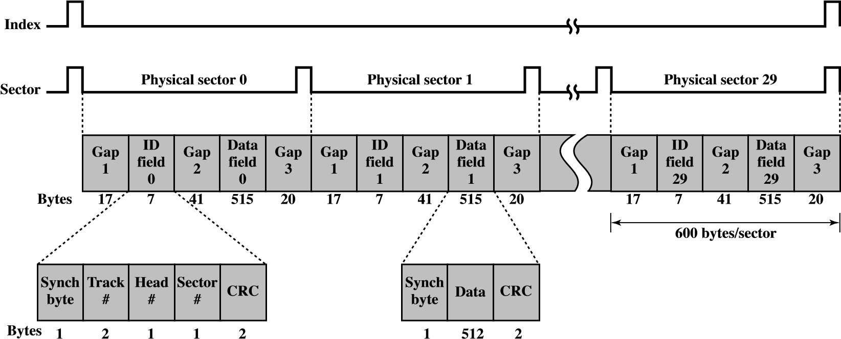
Figure 6.4 Winchester Disk Format (Seagate ST506)
track. All of the heads are mounted on a rigid arm that extends across all tracks; such systems are rare today. In a movable-head disk, there is only one read-write head. Again, the head is mounted on an arm. Because the head must be able to be positioned above any track, the arm can be extended or retracted for this purpose.
The disk itself is mounted in a disk drive, which consists of the arm, a spindle that rotates the disk,and the electronics needed for input and output of binary data. A nonremovable disk is permanently mounted in the disk drive; the hard disk in a personal computer is a nonremovable disk. A removable disk can be removed and replaced with another disk. The advantage of the latter type is that unlimited amounts of data are available with a limited number of disk systems. Furthermore, such a disk may be moved from one computer system to another. Floppy disks and ZIP cartridge disks are examples of removable disks.
For most disks, the magnetizable coating is applied to both sides of the platter, which is then referred to as double sided. Some less expensive disk systems use single-sided disks.
Table 6.1 Physical Characteristics of Disk Systems
Head Motion  Fixed head (one per track)  Movable head (one per surface) | Platters  Single platter  Multiple platter
Disk Portability  Nonremovable disk  Removable disk  Sides  Single sided  Double sided | Head Mechanism  Contact (floppy)  Fixed gap  Aerodynamic gap (Winchester)
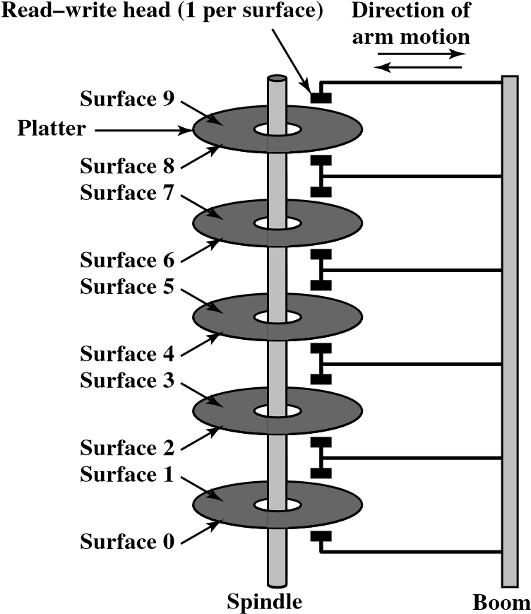
Figure 6.5 Components of a Disk Drive
Some disk drives accommodate multiple platters stacked vertically a fraction of an inch apart.Multiple arms are provided (Figure 6.5).Multiple–platter disks employ a movable head, with one read-write head per platter surface.All of the heads are mechanically fixed so that all are at the same distance from the center of the disk and move together.Thus,at any time,all of the heads are positioned over tracks that are of equal distance from the center of the disk.The set of all the tracks in the same relative position on the platter is referred to as a cylinder. For example, all of the shaded tracks in Figure 6.6 are part of one cylinder.
Finally, the head mechanism provides a classification of disks into three types.
Traditionally, the read-write head has been positioned a fixed distance above the

Figure 6.6 Tracks and Cylinders
platter, allowing an air gap.At the other extreme is a head mechanism that actually comes into physical contact with the medium during a read or write operation.This mechanism is used with the floppy disk, which is a small, flexible platter and the least expensive type of disk.
To understand the third type of disk, we need to comment on the relationship between data density and the size of the air gap. The head must generate or sense an electromagnetic field of sufficient magnitude to write and read properly. The narrower the head is, the closer it must be to the platter surface to function.A narrower head means narrower tracks and therefore greater data density, which is desirable. However, the closer the head is to the disk, the greater the risk of error from impurities or imperfections. To push the technology further, the Winchester disk was developed.Winchester heads are used in sealed drive assemblies that are almost free of contaminants. They are designed to operate closer to the disk’s surface than conventional rigid disk heads, thus allowing greater data density. The head is actually an aerodynamic foil that rests lightly on the platter’s surface when the disk is motionless. The air pressure generated by a spinning disk is enough to make the foil rise above the surface. The resulting noncontact system can be engineered to use narrower heads that operate closer to the platter’s surface than conventional rigid disk heads.
Table 6.2 gives disk parameters for typical contemporary high-performance disks.
Table 6.2 Typical Hard Disk Drive Parameters
Characteristics | Seagate  Barracuda  ES.2 | Seagate  Barracuda  7200.10 | Seagate  Barracuda  7200.9 | Seagate | Hitachi  Microdrive
Application | High-capacity server | High-performance desktop | Entry-level desktop | Laptop | Handheld devices
Capacity | 1 TB | 750 GB | 160 GB | 120 GB | 8 GB
Minimum track-to-track seek time | 0.8 ms | 0.3 ms | 1.0 ms | — | 1.0 ms
Average seek time | 8.5 ms | 3.6 ms | 9.5 ms | 12.5 ms | 12 ms
Spindle speed | 7200 rpm | 7200 rpm | 7200 | 5400 rpm | 3600 rpm
Average rotational delay | 4.16 ms | 4.16 ms | 4.17 ms | 5.6 ms | 8.33 ms
Maximum transfer rate | 3 GB/s | 300 MB/s | 300 MB/s | 150 MB/s | 10 MB/s
Bytes per sector | 512 | 512 | 512 | 512 | 512
Tracks per cylinder (number of platter surfaces) | 8 | 8 | 2 | 8 | 2
Wait for Wait for Seek Rotational Data
device channel delay transfer
Device busy
Figure 6.7 Timing of a Disk I/O Transfer

Disk Performance Parameters
The actual details of disk I/O operation depend on the computer system,the operating system, and the nature of the I/O channel and disk controller hardware.A general timing diagram of disk I/O transfer is shown in Figure 6.7.
When the disk drive is operating,the disk is rotating at constant speed.To read or write,the head must be positioned at the desired track and at the beginning of the desired sector on that track.Track selection involves moving the head in a movablehead system or electronically selecting one head on a fixed-head system.On a movablehead system, the time it takes to position the head at the track is known as seek time. In either case, once the track is selected, the disk controller waits until the appropriate sector rotates to line up with the head.The time it takes for the beginning of the sector to reach the head is known as rotational delay, or rotational latency. The sum of the seek time, if any, and the rotational delay equals the access time, which is the time it takes to get into position to read or write.Once the head is in position, the read or write operation is then performed as the sector moves under the head; this is the data transfer portion of the operation; the time required for the transfer is the transfer time.
In addition to the access time and transfer time, there are several queuing delays normally associated with a disk I/O operation.When a process issues an I/O request, it must first wait in a queue for the device to be available.At that time, the device is assigned to the process. If the device shares a single I/O channel or a set of I/O channels with other disk drives, then there may be an additional wait for the channel to be available.At that point, the seek is performed to begin disk access.
In some high-end systems for servers, a technique known as rotational positional sensing (RPS) is used. This works as follows: When the seek command has been issued, the channel is released to handle other I/O operations.When the seek is completed, the device determines when the data will rotate under the head. As that sector approaches the head, the device tries to reestablish the communication path back to the host. If either the control unit or the channel is busy with another I/O, then the reconnection attempt fails and the device must rotate one whole revolution before it can attempt to reconnect, which is called an RPS miss. This is an extra delay element that must be added to the timeline of Figure 6.7.
SEEK TIME Seek time is the time required to move the disk arm to the required track. It turns out that this is a difficult quantity to pin down.The seek time consists of two key components: the initial startup time, and the time taken to traverse the tracks that have to be crossed once the access arm is up to speed. Unfortunately, the traversal time is not a linear function of the number of tracks, but includes a settling time (time after positioning the head over the target track until track identification is confirmed).
Much improvement comes from smaller and lighter disk components. Some years ago, a typical disk was 14 inches (36 cm) in diameter, whereas the most common size today is 3.5 inches (8.9 cm), reducing the distance that the arm has to travel.A typical average seek time on contemporary hard disks is under 10 ms.
ROTATIONAL DELAY Disks, other than floppy disks, rotate at speeds ranging from 3600 rpm (for handheld devices such as digital cameras) up to, as of this writing, 20,000 rpm; at this latter speed, there is one revolution per 3 ms.Thus, on the average, the rotational delay will be 1.5 ms.
TRANSFER TIME The transfer time to or from the disk depends on the rotation speed of the disk in the following fashion:
_{T} = b
rN
where
T = transfer time b = number of bytes to be transferred
N = number of bytes on a track r = rotation speed, in revolutions per second
Thus the total average access time can be expressed as
Ta = Ts + 1 + b
2r rN
where T_{s} is the average seek time. Note that on a zoned drive, the number of bytes per track is variable, complicating the calculation.
ATIMING COMPARISON With the foregoing parameters defined, let us look at two different I/O operations that illustrate the danger of relying on average values.Consider a disk with an advertised average seek time of 4 ms,rotation speed of 15,000 rpm, and 512-byte sectors with 500 sectors per track. Suppose that we wish to read a file consisting of 2500 sectors for a total of 1.28 Mbytes. We would like to estimate the total time for the transfer.
First, let us assume that the file is stored as compactly as possible on the disk. That is,the file occupies all of the sectors on 5 adjacent tracks (5 tracks × 500 sectors/ track = 2500 sectors). This is known as sequential organization. Now, the time to read the first track is as follows:
Average seek | 4 ms
Average rotational delay | 2 ms
Read 500 sectors | 4 ms

10 ms
Suppose that the remaining tracks can now be read with essentially no seek time. That is, the I/O operation can keep up with the flow from the disk. Then, at most, we need to deal with rotational delay for each succeeding track. Thus each successive track is read in 2 + 4 = 6 ms.To read the entire file,
Total time = 10 + (4 * 6) = 34 ms = 0.034 seconds
Now let us calculate the time required to read the same data using random access rather than sequential access; that is, accesses to the sectors are distributed randomly over the disk. For each sector, we have
Average seek | 4 ms
Rotational delay | 2 ms
Read 1 sectors | 0.008 ms  6.008 ms
Total time = 2500 * 6.008 = 15020 ms = 15.02 seconds
It is clear that the order in which sectors are read from the disk has a tremendous effect on I/O performance. In the case of file access in which multiple sectors are read or written, we have some control over the way in which sectors of data are deployed.However,even in the case of a file access,in a multiprogramming environment, there will be I/O requests competing for the same disk.Thus, it is worthwhile to examine ways in which the performance of disk I/O can be improved over that achieved with purely random access to the disk.This leads to a consideration of disk scheduling algorithms,which is the province of the operating system and beyond the scope of this book (see [STAL09] for a discussion).

RAID Simulator

6.2 RAID
As discussed earlier, the rate in improvement in secondary storage performance has been considerably less than the rate for processors and main memory. This mismatch has made the disk storage system perhaps the main focus of concern in improving overall computer system performance.
As in other areas of computer performance, disk storage designers recognize that if one component can only be pushed so far, additional gains in performance are to be had by using multiple parallel components. In the case of disk storage, this leads to the development of arrays of disks that operate independently and in parallel. With multiple disks, separate I/O requests can be handled in parallel, as long as the data required reside on separate disks. Further, a single I/O request
can be executed in parallel if the block of data to be accessed is distributed across multiple disks.
With the use of multiple disks,there is a wide variety of ways in which the data can be organized and in which redundancy can be added to improve reliability.This could make it difficult to develop database schemes that are usable on a number of platforms and operating systems. Fortunately, industry has agreed on a standardized scheme for multiple-disk database design, known as RAID (Redundant Array of Independent Disks). The RAID scheme consists of seven levels, zero through six. These levels do not imply a hierarchical relationship but designate different design architectures that share three common characteristics:
- RAID is a set of physical disk drives viewed by the operating system as a single logical drive.
- Data are distributed across the physical drives of an array in a scheme known as striping,described subsequently.
- Redundant disk capacity is used to store parity information, which guarantees data recoverability in case of a disk failure.
The details of the second and third characteristics differ for the different RAID levels. RAID 0 and RAID 1 do not support the third characteristic.
The term RAID was originally coined in a paper by a group of researchers at the University of California at Berkeley [PATT88].⁴ The paper outlined various RAID configurations and applications and introduced the definitions of the RAID levels that are still used. The RAID strategy employs multiple disk drives and distributes data in such a way as to enable simultaneous access to data from multiple drives, thereby improving I/O performance and allowing easier incremental increases in capacity.
The unique contribution of the RAID proposal is to address effectively the need for redundancy. Although allowing multiple heads and actuators to operate simultaneously achieves higher I/O and transfer rates, the use of multiple devices increases the probability of failure. To compensate for this decreased reliability, RAID makes use of stored parity information that enables the recovery of data lost due to a disk failure.
We now examine each of the RAID levels.Table 6.3 provides a rough guide to the seven levels. In the table, I/O performance is shown both in terms of data transfer capacity, or ability to move data, and I/O request rate, or ability to satisfy I/O requests, since these RAID levels inherently perform differently relative to these two
Table 6.3 RAID Levels
196
Category | Level | Description | Disks Required | Data Availability | Large I/O Data Transfer Capacity | Small I/O Request Rate
Striping | 0 | Nonredundant | N | Lower than single disk | Very high | Very high for both read and write
Mirroring | 1 | Mirrored | 2N | Higher than RAID 2,  3, 4, or 5; lower than  RAID 6 | Higher than single disk for read; similar to single disk for write | Up to twice that of a single disk for read; similar to single disk for write
Parallel access | 2 | Redundant via Hamming code | N + m | Much higher than single disk; comparable to RAID 3, 4, or 5 | Highest of all listed alternatives | Approximately twice that of a single disk
Parallel access | 3 | Bit-interleaved parity | N + 1 | Much higher than single disk; comparable to RAID 2, 4, or 5 | Highest of all listed alternatives | Approximately twice that of a single disk
Independent access | 4 | Block-interleaved parity | N + 1 | Much higher than single disk; comparable to RAID 2, 3, or 5 | Similar to RAID 0 for read; significantly lower than single disk for write | Similar to RAID 0 for read; significantly lower than single disk for write
Independent access | 5 | Block-interleaved distributed parity | N + 1 | Much higher than single disk; comparable to RAID 2, 3, or 4 | Similar to RAID 0 for read; lower than single disk for write | Similar to RAID 0 for read; generally lower than single disk for write
Independent access | 6 | Block-interleaved dual distributed parity | N + 2 | Highest of all listed alternatives | Similar to RAID 0 for  read; lower than RAID 5 for write | Similar to RAID 0 for read; significantly lower than RAID 5 for write
N = number of data disks; m proportional to log N
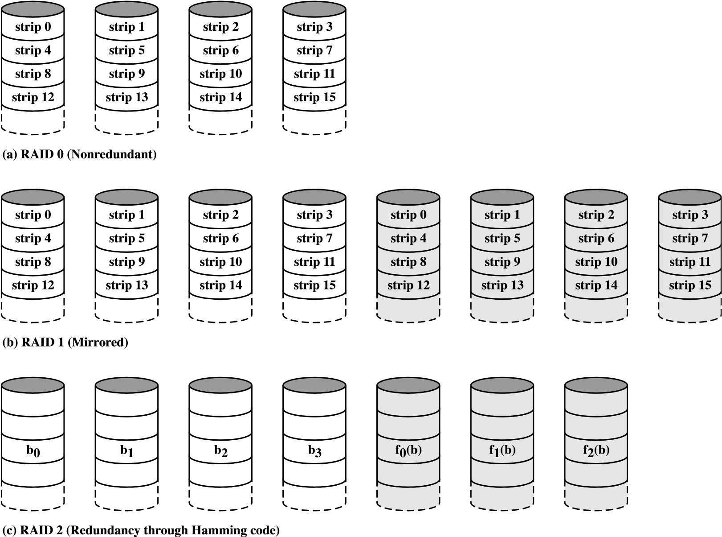
Figure 6.8 RAID Levels
metrics. Each RAID level’s strong point is highlighted by darker shading. Figure 6.8 illustrates the use of the seven RAID schemes to support a data capacity requiring four disks with no redundancy.The figures highlight the layout of user data and redundant data and indicates the relative storage requirements of the various levels. We refer to these figures throughout the following discussion.

RAID Level 0
RAID level 0 is not a true member of the RAID family because it does not include redundancy to improve performance. However, there are a few applications, such as some on supercomputers in which performance and capacity are primary concerns and low cost is more important than improved reliability.
For RAID 0, the user and system data are distributed across all of the disks in the array. This has a notable advantage over the use of a single large disk: If two different I/O requests are pending for two different blocks of data, then there is a good chance that the requested blocks are on different disks.Thus, the two requests can be issued in parallel, reducing the I/O queuing time.
But RAID 0, as with all of the RAID levels, goes further than simply distributing the data across a disk array:The data are striped across the available disks.This is best understood by considering Figure 6.9.All of the user and system data are viewed
d) RAID 3 (Bit-interleaved parity
(
)
b
0
b
1
b
2
b
3
P(b)
block 12
)
e) RAID 4 (Block-level parity
(
block 8
block 4
block 0
block 13
block 9
block 5
block 1
block 14
block 10
block 6
block 2
block 15
block 7
block 3
P(12-15)
P(8-11)
P(4-7)
P(0-3)
block 11
block 12
block 8
block 4
block 0
block 9
block 5
block 1
block 13
block 6
block 2
block 14
block 10
block 3
block 15
P(16-19)
P(12-15)
P(8-11)
P(4-7)
block 16
block 17
block 18
block 19
block 11
block 7
(
f) RAID 5 (Block-level distributed parity
)
P(0-3)
block 12
g) RAID 6 (Dual redundancy)
(
block 8
block 4
block 0
P(12-15)
block 9
block 5
block 1
Q(12-15)
P(8-11)
block 6
block 2
block 13
P(4-7)
block 3
block 14
block 10
Q(4-7)
P(0-3)
Q(8-11)
block 15
block 7
Q(0-3)
block 11
Figure 6.8 RAID Levels (continued)
as being stored on a logical disk. The logical disk is divided into strips; these strips may be physical blocks, sectors, or some other unit. The strips are mapped round robin to consecutive physical disks in the RAID array.A set of logically consecutive strips that maps exactly one strip to each array member is referred to as a stripe. In an n-disk array, the first n logical strips are physically stored as the first strip on each of the n disks,forming the first stripe;the second n strips are distributed as the second
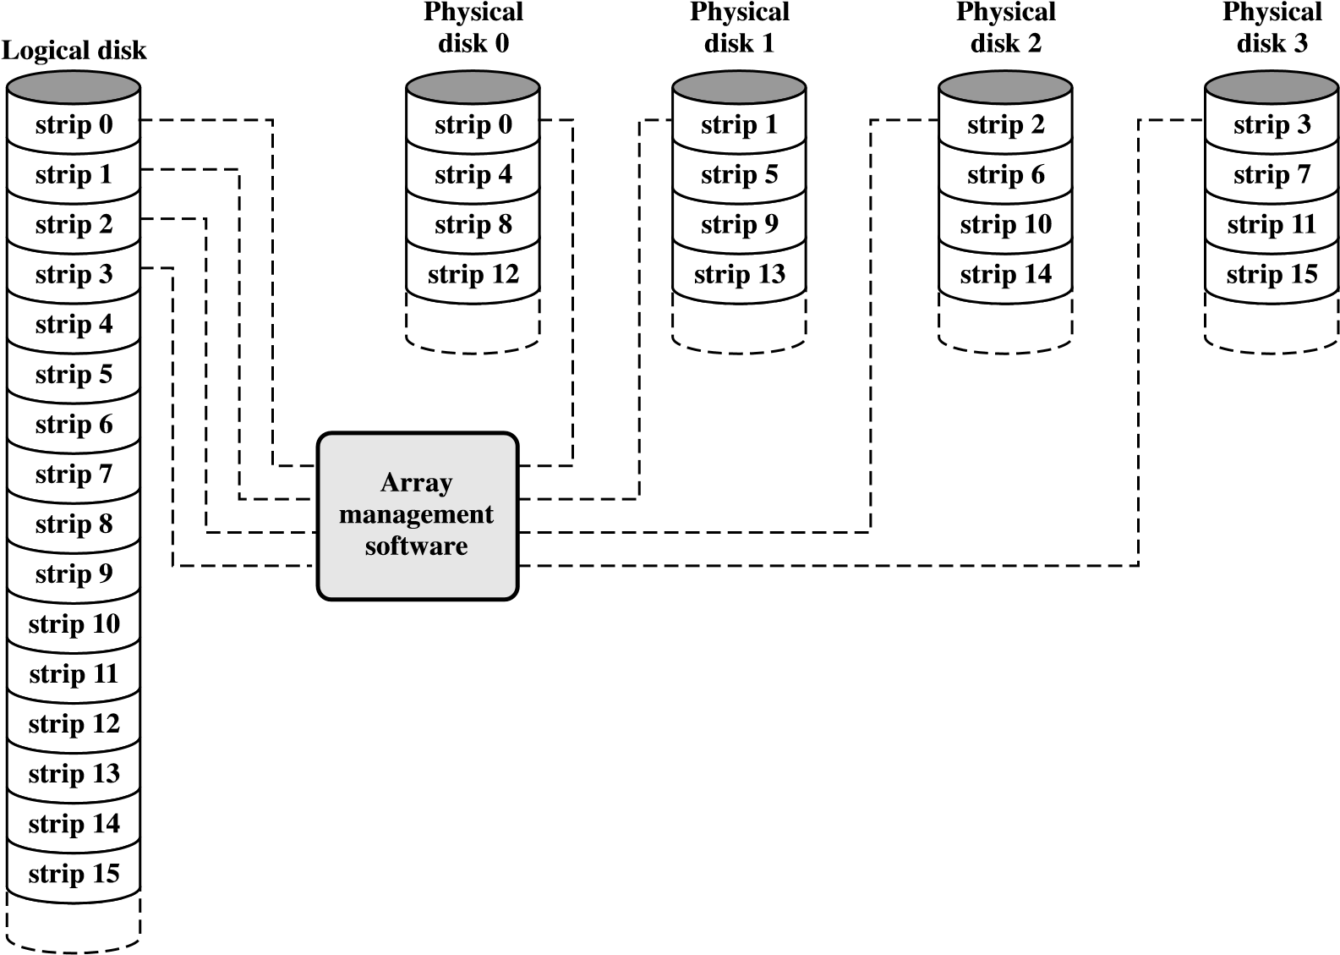
Figure 6.9 Data Mapping for a RAID Level 0 Array
strips on each disk; and so on.The advantage of this layout is that if a single I/O request consists of multiple logically contiguous strips, then up to n strips for that request can be handled in parallel, greatly reducing the I/O transfer time.
Figure 6.9 indicates the use of array management software to map between logical and physical disk space.This software may execute either in the disk subsystem or in a host computer.
RAID 0 FOR HIGH DATA TRANSFER CAPACITY The performance of any of the RAID levels depends critically on the request patterns of the host system and on the layout of the data. These issues can be most clearly addressed in RAID 0, where the impact of redundancy does not interfere with the analysis. First, let us consider the use of RAID 0 to achieve a high data transfer rate. For applications to experience a high transfer rate, two requirements must be met. First, a high transfer capacity must exist along the entire path between host memory and the individual disk drives. This includes internal controller buses, host system I/O buses, I/O adapters, and host memory buses.
The second requirement is that the application must make I/O requests that drive the disk array efficiently. This requirement is met if the typical request is for large amounts of logically contiguous data, compared to the size of a strip. In this case, a single I/O request involves the parallel transfer of data from multiple disks, increasing the effective transfer rate compared to a single-disk transfer.
RAID 0 FOR HIGH I/O REQUEST RATE In a transaction-oriented environment, the user is typically more concerned with response time than with transfer rate.For an individual I/O request for a small amount of data,the I/O time is dominated by the motion of the disk heads (seek time) and the movement of the disk (rotational latency).
In a transaction environment, there may be hundreds of I/O requests per second. A disk array can provide high I/O execution rates by balancing the I/O load across multiple disks. Effective load balancing is achieved only if there are typically multiple I/O requests outstanding.This, in turn, implies that there are multiple independent applications or a single transaction-oriented application that is capable of multiple asynchronous I/O requests.The performance will also be influenced by the strip size. If the strip size is relatively large, so that a single I/O request only involves a single disk access, then multiple waiting I/O requests can be handled in parallel, reducing the queuing time for each request.

RAID Level 1
RAID 1 differs from RAID levels 2 through 6 in the way in which redundancy is achieved. In these other RAID schemes, some form of parity calculation is used to introduce redundancy, whereas in RAID 1, redundancy is achieved by the simple expedient of duplicating all the data.As Figure 6.8b shows,data striping is used,as in RAID 0. But in this case, each logical strip is mapped to two separate physical disks so that every disk in the array has a mirror disk that contains the same data. RAID 1 can also be implemented without data striping, though this is less common. There are a number of positive aspects to the RAID 1 organization:
- A read request can be serviced by either of the two disks that contains the requested data,whichever one involves the minimum seek time plus rotational latency.
- A write request requires that both corresponding strips be updated, but this can be done in parallel.Thus, the write performance is dictated by the slower of the two writes (i.e.,the one that involves the larger seek time plus rotational latency). However, there is no “write penalty” with RAID 1. RAID levels 2 through 6 involve the use of parity bits. Therefore, when a single strip is updated, the array management software must first compute and update the parity bits as well as updating the actual strip in question.
- Recovery from a failure is simple.When a drive fails, the data may still be accessed from the second drive.
The principal disadvantage of RAID 1 is the cost; it requires twice the disk space of the logical disk that it supports. Because of that, a RAID 1 configuration is likely to be limited to drives that store system software and data and other highly critical files. In these cases, RAID 1 provides real-time copy of all data so that in the event of a disk failure, all of the critical data are still immediately available.
In a transaction-oriented environment, RAID 1 can achieve high I/O request rates if the bulk of the requests are reads. In this situation, the performance of RAID 1 can approach double of that of RAID 0. However, if a substantial fraction of the I/O requests are write requests, then there may be no significant performance gain over RAID 0. RAID 1 may also provide improved performance over RAID 0 for data transfer intensive applications with a high percentage of reads. Improvement occurs if the application can split each read request so that both disk members participate.

RAID Level 2
RAID levels 2 and 3 make use of a parallel access technique. In a parallel access array, all member disks participate in the execution of every I/O request. Typically, the spindles of the individual drives are synchronized so that each disk head is in the same position on each disk at any given time.
As in the other RAID schemes, data striping is used. In the case of RAID 2 and 3, the strips are very small, often as small as a single byte or word.With RAID 2, an error-correcting code is calculated across corresponding bits on each data disk, and the bits of the code are stored in the corresponding bit positions on multiple parity disks. Typically, a Hamming code is used, which is able to correct single-bit errors and detect double-bit errors.
Although RAID 2 requires fewer disks than RAID 1, it is still rather costly. The number of redundant disks is proportional to the log of the number of data disks. On a single read, all disks are simultaneously accessed. The requested data and the associated error-correcting code are delivered to the array controller. If there is a single-bit error, the controller can recognize and correct the error instantly, so that the read access time is not slowed. On a single write, all data disks and parity disks must be accessed for the write operation.
RAID 2 would only be an effective choice in an environment in which many disk errors occur. Given the high reliability of individual disks and disk drives, RAID 2 is overkill and is not implemented.

RAID Level 3
RAID 3 is organized in a similar fashion to RAID 2.The difference is that RAID 3 requires only a single redundant disk, no matter how large the disk array. RAID 3 employs parallel access, with data distributed in small strips. Instead of an error-correcting code,a simple parity bit is computed for the set of individual bits in the same position on all of the data disks.
REDUNDANCY In the event of a drive failure,the parity drive is accessed and data is reconstructed from the remaining devices. Once the failed drive is replaced, the missing data can be restored on the new drive and operation resumed.
Data reconstruction is simple. Consider an array of five drives in which X0 through X3 contain data and X4 is the parity disk.The parity for the ith bit is calculated as follows:
X4(i) = X3(i) { X2(i) { X1(i) { X0(i)
where { is exclusive-OR function.
Suppose that drive X1 has failed. If we add X4(i) { X1(i) to both sides of the preceding equation, we get
X1(i) = X4(i) { X3(i) { X2(i) { X0(i)
Thus, the contents of each strip of data on X1 can be regenerated from the contents of the corresponding strips on the remaining disks in the array.This principle is true for RAID levels 3 through 6.
In the event of a disk failure, all of the data are still available in what is referred to as reduced mode. In this mode, for reads, the missing data are regenerated on the fly using the exclusive-OR calculation. When data are written to a reduced RAID 3 array, consistency of the parity must be maintained for later regeneration. Return to full operation requires that the failed disk be replaced and the entire contents of the failed disk be regenerated on the new disk.
PERFORMANCE Because data are striped in very small strips, RAID 3 can achieve very high data transfer rates. Any I/O request will involve the parallel transfer of data from all of the data disks. For large transfers, the performance improvement is especially noticeable. On the other hand, only one I/O request can be executed at a time.Thus, in a transaction-oriented environment, performance suffers.

RAID Level 4
RAID levels 4 through 6 make use of an independent access technique. In an independent access array, each member disk operates independently, so that separate I/O requests can be satisfied in parallel. Because of this, independent access arrays are more suitable for applications that require high I/O request rates and are relatively less suited for applications that require high data transfer rates.
As in the other RAID schemes, data striping is used. In the case of RAID 4 through 6, the strips are relatively large.With RAID 4, a bit-by-bit parity strip is calculated across corresponding strips on each data disk, and the parity bits are stored in the corresponding strip on the parity disk.
RAID 4 involves a write penalty when an I/O write request of small size is performed. Each time that a write occurs, the array management software must update not only the user data but also the corresponding parity bits. Consider an array of five drives in which X0 through X3 contain data and X4 is the parity disk. Suppose that a write is performed that only involves a strip on disk X1. Initially, for each bit i, we have the following relationship:
X4(i) = X3(i) { X2(i) { X1(i) { X0(i) (6.1)
After the update, with potentially altered bits indicated by a prime symbol:
X4¿(i) = X3(i) { X2(i) { X1¿(i) { X0(i)
= X3(i) { X2(i) { X1¿(i) { X0(i) { X1(i) { X1(i) = X3(i) { X2(i) { X1(i) { X0(i) { X1(i) { X1¿(i)
= X4(i) { X1(i) { X1¿(i)
The preceding set of equations is derived as follows.The first line shows that a change in X1 will also affect the parity disk X4.In the second line,we add the terms { X1(i) { X1(i)]. Because the exclusive-OR of any quantity with itself is 0, this does not affect the equation. However, it is a convenience that is used to create the third line, by reordering. Finally, Equation (6.1) is used to replace the first four terms by X4(i).
To calculate the new parity, the array management software must read the old user strip and the old parity strip. Then it can update these two strips with the new data and the newly calculated parity. Thus, each strip write involves two reads and two writes.
In the case of a larger size I/O write that involves strips on all disk drives, parity is easily computed by calculation using only the new data bits.Thus, the parity drive can be updated in parallel with the data drives and there are no extra reads or writes.
In any case, every write operation must involve the parity disk, which therefore can become a bottleneck.

RAID Level 5
RAID 5 is organized in a similar fashion to RAID 4.The difference is that RAID 5 distributes the parity strips across all disks. A typical allocation is a round-robin scheme,as illustrated in Figure 6.8f.For an n-disk array,the parity strip is on a different disk for the first n stripes, and the pattern then repeats.
The distribution of parity strips across all drives avoids the potential I/O bottleneck found in RAID 4.

RAID Level 6
RAID 6 was introduced in a subsequent paper by the Berkeley researchers [KATZ89]. In the RAID 6 scheme, two different parity calculations are carried out and stored in separate blocks on different disks. Thus, a RAID 6 array whose user data require N disks consists of N + 2 disks.
Figure 6.8g illustrates the scheme. P and Q are two different data check algorithms. One of the two is the exclusive-OR calculation used in RAID 4 and 5. But the other is an independent data check algorithm.This makes it possible to regenerate data even if two disks containing user data fail.
The advantage of RAID 6 is that it provides extremely high data availability. Three disks would have to fail within the MTTR (mean time to repair) interval to cause data to be lost. On the other hand, RAID 6 incurs a substantial write penalty, because each write affects two parity blocks. Performance benchmarks [EISC07] show a RAID 6 controller can suffer more than a 30% drop in overall write performance compared with a RAID 5 implementation. RAID 5 and RAID 6 read performance is comparable.
Table 6.4 is a comparative summary of the seven levels.

6.3 OPTICAL MEMORY
In 1983, one of the most successful consumer products of all time was introduced: the compact disk (CD) digital audio system.The CD is a nonerasable disk that can store more than 60 minutes of audio information on one side.The huge commercial success of the CD enabled the development of low-cost optical-disk storage technology that has revolutionized computer data storage. A variety of optical-disk systems have been introduced (Table 6.5).We briefly review each of these.
Table 6.4 RAID Comparison
Level | Advantages | Disadvantages | Applications
0 | I/O performance is greatly improved by spreading the I/O load across many channels and drives  No parity calculation overhead is involved  Very simple design  Easy to implement | The failure of just one drive will result in all data in an array being lost | Video production and editing  Image Editing  Pre-press applications  Any application requiring  high bandwidth
1 | 100% redundancy of data means no rebuild is necessary in case of a disk failure, just a copy to the replacement disk  Under certain circumstances, RAID 1 can sustain multiple simultaneous drive failures  Simplest RAID storage subsystem design | Highest disk overhead of all RAID types (100%)—inefficient | Accounting  Payroll  Financial  Any application requiring very high availability
2 | Extremely high data transfer rates possible  The higher the data transfer rate required, the better the ratio of data disks to ECC disks  Relatively simple controller design compared to RAID levels 3, 4 & 5 | Very high ratio of ECC disks to data disks with smaller word sizes— inefficient  Entry level cost very high—requires very high transfer rate requirement to justify | No commercial implementations exist/ not commercially viable
3 | Very high read data transfer rate  Very high write data transfer rate  Disk failure has an insignificant impact on throughput  Low ratio of ECC (parity) disks to data disks means high efficiency | Transaction rate equal to that of a single disk drive at best (if spindles are synchronized)  Controller design is fairly complex | Video production and live streaming  Image editing  Video editing  Prepress applications  Any application requiring high throughput
4 | Very high Read data transaction rate  Low ratio of ECC (parity) disks to data disks means high efficiency | Quite complex controller design  Worst write transaction rate and Write aggregate transfer rate  Difficult and inefficient data rebuild in the event of disk failure | No commercial implementations exist/ not commercially viable
(Continued)
Table 6.4 Continued
Level | Advantages | Disadvantages | Applications
5 | Highest Read data transaction rate  Low ratio of ECC (parity) disks to data disks means high efficiency Good aggregate transfer rate | Most complex controller design  Difficult to rebuild in the event of a disk failure (as compared to RAID level 1) | File and application servers  Database servers  Web, e-mail, and news servers  Intranet servers  Most versatile RAID level
6 | Provides for an extremely high data fault tolerance and can sustain multiple simultaneous drive failures | More complex controller design  Controller overhead to compute parity addresses is extremely high | Perfect solution for mission critical applications
Table 6.5 Optical Disk Products
CD
Compact Disk.A nonerasable disk that stores digitized audio information.The standard system uses 12-cm disks and can record more than 60 minutes of uninterrupted playing time.
CD-ROM
Compact Disk Read-Only Memory.A nonerasable disk used for storing computer data.The standard system uses 12-cm disks and can hold more than 650 Mbytes.
CD-R CD Recordable. Similar to a CD-ROM.The user can write to the disk only once.
CD-RW
CD Rewritable. Similar to a CD-ROM.The user can erase and rewrite to the disk multiple times.
DVD
Digital Versatile Disk.A technology for producing digitized, compressed representation of video information, as well as large volumes of other digital data. Both 8 and 12 cm diameters are used, with a double-sided capacity of up to 17 Gbytes.The basic DVD is read-only (DVD-ROM).
DVD-R
DVD Recordable. Similar to a DVD-ROM.The user can write to the disk only once. Only one-sided disks can be used.
DVD-RW
DVD Rewritable. Similar to a DVD-ROM.The user can erase and rewrite to the disk multiple times. Only one-sided disks can be used.
Blu-Ray DVD
High definition video disk. Provides considerably greater data storage density than DVD, using a 405-nm (blue-violet) laser.A single layer on a single side can store 25 Gbytes.
Polycarbonate
plastic
Protective
acrylic
Aluminum
Laser transmit/
receive
Pit
Land
Label
Figure 6.10 CD Operation

Compact Disk
CD-ROM Both the audio CD and the CD-ROM (compact disk read-only memory) share a similar technology. The main difference is that CD-ROM players are more rugged and have error correction devices to ensure that data are properly transferred from disk to computer. Both types of disk are made the same way.The disk is formed from a resin, such as polycarbonate. Digitally recorded information (either music or computer data) is imprinted as a series of microscopic pits on the surface of the polycarbonate.This is done,first of all,with a finely focused,high-intensity laser to create a master disk.The master is used, in turn, to make a die to stamp out copies onto polycarbonate. The pitted surface is then coated with a highly reflective surface, usually aluminum or gold.This shiny surface is protected against dust and scratches by a top coat of clear acrylic.Finally,a label can be silkscreened onto the acrylic.
Information is retrieved from a CD or CD-ROM by a low-powered laser housed in an optical-disk player, or drive unit. The laser shines through the clear polycarbonate while a motor spins the disk past it (Figure 6.10).The intensity of the reflected light of the laser changes as it encounters a pit. Specifically, if the laser beam falls on a pit, which has a somewhat rough surface, the light scatters and a low intensity is reflected back to the source. The areas between pits are called lands. A land is a smooth surface,which reflects back at higher intensity.The change between pits and lands is detected by a photosensor and converted into a digital signal. The sensor tests the surface at regular intervals.The beginning or end of a pit represents a 1; when no change in elevation occurs between intervals, a 0 is recorded.
Recall that on a magnetic disk, information is recorded in concentric tracks. With the simplest constant angular velocity (CAV) system, the number of bits per track is constant.An increase in density is achieved with multiple zoned recording, in which the surface is divided into a number of zones, with zones farther from the center containing more bits than zones closer to the center.Although this technique increases capacity, it is still not optimal.
To achieve greater capacity, CDs and CD-ROMs do not organize information on concentric tracks. Instead, the disk contains a single spiral track, beginning near
00 | FF ... FF | 00 | MIN | SEC | Sector | Mode | Data | Layered  ECC
bytes
12
SYNC
bytes
4
ID
2048
bytes
Data
288
bytes
L-ECC
bytes
2352
Figure 6.11 CD-ROM Block Format
the center and spiraling out to the outer edge of the disk.Sectors near the outside of the disk are the same length as those near the inside. Thus, information is packed evenly across the disk in segments of the same size and these are scanned at the same rate by rotating the disk at a variable speed.The pits are then read by the laser at a constant linear velocity (CLV). The disk rotates more slowly for accesses near the outer edge than for those near the center. Thus, the capacity of a track and the rotational delay both increase for positions nearer the outer edge of the disk. The data capacity for a CD-ROM is about 680 MB.
Data on the CD-ROM are organized as a sequence of blocks.A typical block format is shown in Figure 6.11. It consists of the following fields:
- Sync: The sync field identifies the beginning of a block. It consists of a byte of all 0s, 10 bytes of all 1s, and a byte of all 0s.
- Header: The header contains the block address and the mode byte. Mode 0 specifies a blank data field; mode 1 specifies the use of an error-correcting code and 2048 bytes of data; mode 2 specifies 2336 bytes of user data with no error-correcting code.
- Data: User data.
- Auxiliary: Additional user data in mode 2. In mode 1, this is a 288-byte errorcorrecting code.
With the use of CLV, random access becomes more difficult. Locating a specific address involves moving the head to the general area, adjusting the rotation speed and reading the address, and then making minor adjustments to find and access the specific sector.
CD-ROM is appropriate for the distribution of large amounts of data to a large number of users. Because of the expense of the initial writing process, it is not appropriate for individualized applications. Compared with traditional magnetic disks, the CD-ROM has two advantages:
- The optical disk together with the information stored on it can be mass replicated inexpensively—unlike a magnetic disk. The database on a magnetic disk has to be reproduced by copying one disk at a time using two disk drives.
- The optical disk is removable, allowing the disk itself to be used for archival storage. Most magnetic disks are nonremovable. The information on nonremovable magnetic disks must first be copied to another storage medium before the disk drive/disk can be used to store new information.
The disadvantages of CD-ROM are as follows:
- It is read-only and cannot be updated.
- It has an access time much longer than that of a magnetic disk drive, as much as half a second.
CD RECORDABLE To accommodate applications in which only one or a small number of copies of a set of data is needed,the write-once read-many CD,known as the CD recordable (CD-R), has been developed. For CD-R, a disk is prepared in such a way that it can be subsequently written once with a laser beam of modest intensity.Thus, with a somewhat more expensive disk controller than for CD-ROM, the customer can write once as well as read the disk.
The CD-R medium is similar to but not identical to that of a CD or CD-ROM. For CDs and CD-ROMs, information is recorded by the pitting of the surface of the medium, which changes reflectivity. For a CD-R, the medium includes a dye layer. The dye is used to change reflectivity and is activated by a high-intensity laser.The resulting disk can be read on a CD-R drive or a CD-ROM drive.
The CD-R optical disk is attractive for archival storage of documents and files. It provides a permanent record of large volumes of user data.
CD REWRITABLE The CD-RW optical disk can be repeatedly written and overwritten, as with a magnetic disk.Although a number of approaches have been tried, the only pure optical approach that has proved attractive is called phase change. The phase change disk uses a material that has two significantly different reflectivities in two different phase states. There is an amorphous state, in which the molecules exhibit a random orientation that reflects light poorly;and a crystalline state,which has a smooth surface that reflects light well.A beam of laser light can change the material from one phase to the other. The primary disadvantage of phase change optical disks is that the material eventually and permanently loses its desirable properties. Current materials can be used for between 500,000 and 1,000,000 erase cycles.
The CD-RW has the obvious advantage over CD-ROM and CD-R that it can be rewritten and thus used as a true secondary storage. As such, it competes with magnetic disk.A key advantage of the optical disk is that the engineering tolerances for optical disks are much less severe than for high-capacity magnetic disks. Thus, they exhibit higher reliability and longer life.

Digital Versatile Disk
With the capacious digital versatile disk (DVD), the electronics industry has at last found an acceptable replacement for the analog VHS video tape. The DVD has replaced the videotape used in video cassette recorders (VCRs) and, more important for this discussion, replace the CD-ROM in personal computers and servers. The DVD takes video into the digital age.It delivers movies with impressive picture quality, and it can be randomly accessed like audio CDs, which DVD machines can also play. Vast volumes of data can be crammed onto the disk, currently seven times as
Protective layer (acrylic)
1.2
mm
thick
Label
Reflective layer
(
aluminum
)
Polycarbonate substrate
Laser focuses on polycarbonate
pits in front of reflective layer.
(
a) CD-ROM–Capacity 682 MB
(plastic)
mm
1.2
thick
Polycarbonate substrate, side 2
Semireflective layer, side 2
Polycarbonate layer, side 2
Fully reflective layer, side 2
Fully reflective layer, side 1
Polycarbonate layer, side 1
Semireflective layer, side 1
Polycarbonate substrate, side 1
Laser focuses on pits in one layer
on one side at a time. Disk must
be flipped to read other side.
(b) DVD-ROM, double-sided, dual-layer–Capacity 17 GB
Figure 6.12 CD-ROM and DVD-ROM
much as a CD-ROM.With DVD’s huge storage capacity and vivid quality, PC games have become more realistic and educational software incorporates more video. Following in the wake of these developments has been a new crest of traffic over the Internet and corporate intranets, as this material is incorporated into Web sites.
The DVD’s greater capacity is due to three differences from CDs (Figure 6.12):
- Bits are packed more closely on a DVD.The spacing between loops of a spiral on a CD is 1.6 m and the minimum distance between pits along the spiral ism 0.834mm.TheDVDusesalaserwithshorterwavelengthandachievesaloopspacingof0.74 mmandaminimumdistancebetweenpitsof0.4 mm.Theresultofthese two improvements is about a seven-fold increase in capacity,to about 4.7 GB.
- The DVD employs a second layer of pits and lands on top of the first layer.A duallayer DVD has a semireflective layer on top of the reflective layer,and by adjusting focus, the lasers in DVD drives can read each layer separately.This technique almost doubles the capacity of the disk, to about 8.5 GB.The lower reflectivity of the second layer limits its storage capacity so that a full doubling is not achieved.
- The DVD-ROM can be two sided,whereas data are recorded on only one side of a CD.This brings total capacity up to 17 GB.
As with the CD,DVDs come in writeable as well as read-only versions (Table 6.5).
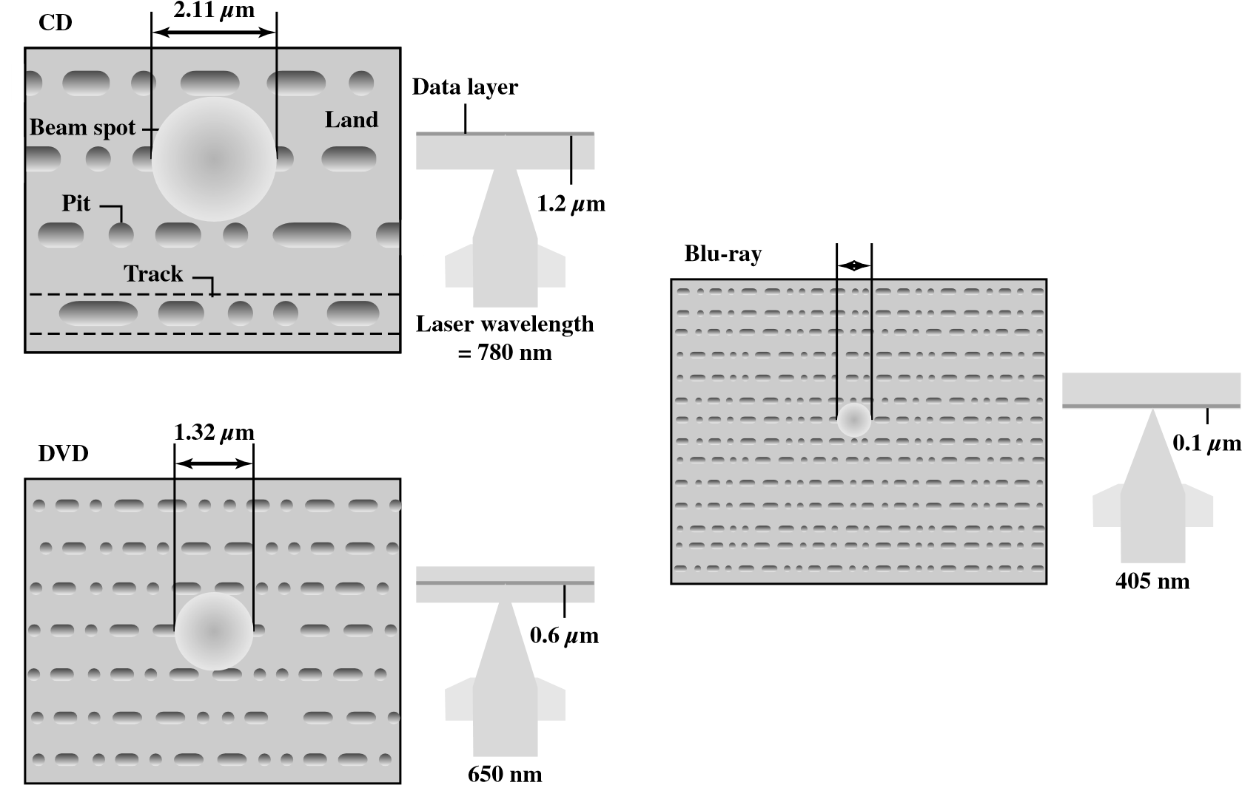0.58 μm
Figure 6.13 Optical Memory Characteristics

High-Definition Optical Disks
High-definition optical disks are designed to store high-definition videos and to provide significantly greater storage capacity compared to DVDs. The higher bit density is achieved by using a laser with a shorter wavelength, in the blue-violet range.The data pits, which constitute the digital 1s and 0s, are smaller on the highdefinition optical disks compared to DVD because of the shorter laser wavelength.
Two competing disk formats and technologies initially competed for market acceptance:HD DVD and Blu-ray DVD.The Blu-ray scheme ultimately achieved market dominance.The HD DVD scheme can store 15 GB on a single layer on a single side. Blu-ray positions the data layer on the disk closer to the laser (shown on the right-hand side of each diagram in Figure 6.13).This enables a tighter focus and less distortion and thus smaller pits and tracks.Blu-ray can store 25 GB on a single layer.Three versions are available:read only (BD-ROM),recordable once (BD-R),and rerecordable (BD-RE).

6.4 MAGNETIC TAPE
Tape systems use the same reading and recording techniques as disk systems. The medium is flexible polyester (similar to that used in some clothing) tape coated with magnetizable material.The coating may consist of particles of pure metal in special binders or vapor-plated metal films. The tape and the tape drive are analogous to a home tape recorder system. Tape widths vary from 0.38 cm (0.15 inch) to 1.27 cm
6.4 / MAGNETIC TAPE
(0.5 inch).Tapes used to be packaged as open reels that have to be threaded through a second spindle for use.Today, virtually all tapes are housed in cartridges.
Data on the tape are structured as a number of parallel tracks running lengthwise. Earlier tape systems typically used nine tracks.This made it possible to store data one byte at a time, with an additional parity bit as the ninth track. This was followed by tape systems using 18 or 36 tracks, corresponding to a digital word or double word.The recording of data in this form is referred to as parallel recording. Most modern systems instead use serial recording, in which data are laid out as a sequence of bits along each track, as is done with magnetic disks.As with the disk, data are read and written in contiguous blocks, called physical records, on a tape. Blocks on the tape are separated by gaps referred to as interrecord gaps. As with the disk, the tape is formatted to assist in locating physical records.
The typical recording technique used in serial tapes is referred to as serpentine recording. In this technique, when data are being recorded, the first set of bits is recorded along the whole length of the tape. When the end of the tape is reached, the heads are repositioned to record a new track, and the tape is again recorded on its whole length, this time in the opposite direction.That process continues, back and forth, until the tape is full (Figure 6.14a). To increase speed, the
Bottom
edge of tape
Direction of
read—write
Track 0
Track 1
Track 2
- Serpentine reading and writing
Track 3
4 |  | 8 |  | 12 |  | 16 |  | 20
Track 2
3 |  | 7 |  | 11 |  | 15 |  | 19
Track 1
2 |  | 6 |  | 10 |  | 14 |  | 18
Track 0
1 |  | 5 |  | 9 |  | 13 |  | 17
Direction of tape motion
- Block layout for system that reads—writes four tracks simultaneously
Figure 6.14 Typical Magnetic Tape Features
Table 6.6 LTO Tape Drives
 | LTO-1 | LTO-2 | LTO-3 | LTO-4 | LTO-5 | LTO-6
Release date | 2000 | 2003 | 2005 | 2007 | TBA | TBA
Compressed capacity | 200 GB | 400 GB | 800 GB | 1600 GB | 3.2 TB | 6.4 TB
Compressed transfer rate (MB/s) | 40 | 80 | 160 | 240 | 360 | 540
Linear density  (bits/mm) | 4880 | 7398 | 9638 | 13300
Tape tracks | 384 | 512 | 704 | 896
Tape length | 609 m | 609 m | 680 m | 820 m
Tape width (cm) | 1.27 | 1.27 | 1.27 | 1.27
Write elements | 8 | 8 | 16 | 16
read-write head is capable of reading and writing a number of adjacent tracks simultaneously (typically two to eight tracks). Data are still recorded serially along individual tracks, but blocks in sequence are stored on adjacent tracks, as suggested by Figure 6.14b.
A tape drive is a sequential-access device. If the tape head is positioned at record 1,then to read record N, it is necessary to read physical records 1 through N - 1, one at a time.If the head is currently positioned beyond the desired record,it is necessary to rewind the tape a certain distance and begin reading forward. Unlike the disk, the tape is in motion only during a read or write operation.
In contrast to the tape, the disk drive is referred to as a direct-access device.A disk drive need not read all the sectors on a disk sequentially to get to the desired one.It must only wait for the intervening sectors within one track and can make successive accesses to any track.
Magnetic tape was the first kind of secondary memory. It is still widely used as the lowest-cost, slowest-speed member of the memory hierarchy.
The dominant tape technology today is a cartridge system known as linear tape-open (LTO). LTO was developed in the late 1990s as an open-source alternative to the various proprietary systems on the market. Table 6.6 shows parameters for the various LTO generations. See Appendix J for details.

6.5 RECOMMENDED READING AND WEB SITES
[JACO08] provides solid coverage of magnetic disks.[MEE96a] provides a good survey of the underlying recording technology of disk and tape systems. [MEE96b] focuses on the data storage techniques for disk and tape systems. [COME00] is a short but instructive article on
6.5 / RECOMMENDED READING AND WEB SITES
current trends in magnetic disk storage technology. [RADD08] and [ANDE03] provide a more recent discussion of magnetic disk storage technology.
An excellent survey of RAID technology, written by the inventors of the RAID concept, is [CHEN94].A good overview paper is [FRIE96].A good performance comparison of the RAID architectures is [CHEN96].
[MARC90] gives an excellent overview of the optical storage field. A good survey of the underlying recording and reading technology is [MANS97].
[ROSC03] provides a comprehensive overview of all types of external memory systems, with a modest amount of technical detail on each. [KHUR01] is another good survey.
[HAEU07] provides a detailed treatment of LTO.
ANDE03 Anderson, D. “You Don’t Know Jack About Disks.” ACM Queue, June
2003.
CHEN94 Chen, P.; Lee, E.; Gibson, G.; Katz, R.; and Patterson, D. “RAID: HighPerformance, Reliable Secondary Storage.” ACM Computing Surveys, June 1994.
CHEN96 Chen,S.,and Towsley,D.“A Performance Evaluation of RAID Architectures.” IEEE Transactions on Computers, October 1996.
COME00 Comerford, R. “Magnetic Storage: The Medium that Wouldn’t Die.” IEEE Spectrum, December 2000.
FRIE96 Friedman, M. “RAID Keeps Going and Going and . . .” IEEE Spectrum, April 1996.
HAUE08 Haeusser, B., et al. IBM System Storage Tape Library Guide for Open Systems. IBM Redbook SG24-5946-05, October 2007. ibm.com/redbooks
JACO08 Jacob, B.; Ng, S.; and Wang, D. Memory Systems: Cache, DRAM, Disk. Boston: Morgan Kaufmann, 2008.
KHUR01 Khurshudov, A.The Essential Guide to Computer Data Storage. Upper Saddle River, NJ: Prentice Hall, 2001.
MANS97 Mansuripur, M., and Sincerbox, G.“Principles and Techniques of Optical Data Storage.” Proceedings of the IEEE, November 1997.
MARC90 Marchant,A. Optical Recording. Reading, MA:Addison-Wesley, 1990.
MEE96a Mee, C., and Daniel, E. eds. Magnetic Recording Technology. New York: McGraw-Hill, 1996.
MEE96b Mee, C., and Daniel, E. eds. Magnetic Storage Handbook. New York: McGrawHill, 1996.
RADD08 Radding,A.“Small Disks, Big Specs.” Storage Magazine, September 2008
ROSC03 Rosch, W. Winn L. Rosch Hardware Bible. Indianapolis, IN: Que Publishing, 2003.
Recommended Web sites:
- Optical Storage Technology Association: Good source of information about optical storage technology and vendors, plus extensive list of relevant links
- LTO Web site: Provides information about LTO technology and licensed vendors

6.6 KEY TERMS,REVIEW QUESTIONS,AND PROBLEMS

Key Terms
access time  Blu-ray  CD  CD-ROM  CD-R  CD-RW  constant angular velocity  (CAV)  constant linear velocity (CLV)  cylinder  DVD  DVD-ROM  DVD-R | DVD-RW  fixed-head disk  floppy disk gap head land magnetic disk magnetic tape magnetoresistive movable-head disk multiple zoned recording nonremovable disk optical memory | pit platter  RAID  removable disk rotational delay sector seek time  serpentine recording striped data substrate track transfer time

Review Questions
6.1 What are the advantages of using a glass substrate for a magnetic disk?
6.2 How are data written onto a magnetic disk?
6.3 How are data read from a magnetic disk?
6.4 Explain the difference between a simple CAV system and a multiple zoned recording system.
6.5 Define the terms track, cylinder, and sector.
6.6 What is the typical disk sector size?
6.7 Define the terms seek time, rotational delay, access time, and transfer time.
6.8 What common characteristics are shared by all RAID levels?
6.9 Briefly define the seven RAID levels.
6.10 Explain the term striped data.
6.11 How is redundancy achieved in a RAID system?
6.12 In the context of RAID, what is the distinction between parallel access and independent access?
6.13 What is the difference between CAV and CLV?
6.14 What differences between a CD and a DVD account for the larger capacity of the latter?
6.15 Explain serpentine recording.

Problems
6.1 Consider a disk with N tracks numbered from 0 to (N 1) and assume that requested sectors are distributed randomly and evenly over the disk.We want to calculate the average number of tracks traversed by a seek.
- First, calculate the probability of a seek of length j when the head is currently positioned over track t. Hint: This is a matter of determining the total number of combinations, recognizing that all track positions for the destination of the seek are equally likely.
6.6 / KEY TERMS,REVIEW QUESTIONS,AND PROBLEMS
- Next, calculate the probability of a seek of length K. Hint: this involves the summing over all possible combinations of movements of K tracks.
- Calculate the average number of tracks traversed by a seek, using the formula for expected value
N -1
E[x] = a i * Pr[x = i]
i=0
Hint: Use the equalities: a^{n} i = n(n + 1); a^{n} i₂ = n(n + 1)(2n + 1).
i=1 2 _{i}=1 6
- Show that for large values of N, the average number of tracks traversed by a seek approaches N/3.
6.2 Define the following for a disk system: t_{s} = seek time; average time to position head over track
r = rotation speed of the disk, in revolutions per second
n = number of bits per sector N = capacity of a track, in bits t_{A} = time to access a sector
Develop a formula for t_{A} as a function of the other parameters.
6.3 Consider a magnetic disk drive with 8 surfaces, 512 tracks per surface, and 64 sectors per track. Sector size is 1 KB.The average seek time is 8 ms, the track-to-track access time is 1.5 ms,and the drive rotates at 3600 rpm.Successive tracks in a cylinder can be read without head movement. a. What is the disk capacity?
- What is the average access time? Assume this file is stored in successive sectors and tracks of successive cylinders, starting at sector 0, track 0, of cylinder i.
- Estimate the time required to transfer a 5-MB file.
- What is the burst transfer rate?
6.4 Consider a single-platter disk with the following parameters: rotation speed: 7200 rpm; number of tracks on one side of platter: 30,000; number of sectors per track: 600; seek time: one ms for every hundred tracks traversed. Let the disk receive a request to access a random sector on a random track and assume the disk head starts at track 0.
- What is the average seek time?
- What is the average rotational latency?
- What is the transfer time for a sector?
- What is the total average time to satisfy a request?
6.5 A distinction is made between physical records and logical records.A logical record is a collection of related data elements treated as a conceptual unit,independent of how or where the information is stored.A physical record is a contiguous area of storage space that is defined by the characteristics of the storage device and operating system. Assume a disk system in which each physical record contains thirty 120-byte logical records. Calculate how much disk space (in sectors, tracks, and surfaces) will be required to store 300,000 logical records if the disk is fixed-sector with 512 bytes/sector, with 96 sectors/track, 110 tracks per surface, and 8 usable surfaces. Ignore any file header record(s) and track indexes, and assume that records cannot span two sectors. 6.6 Consider a disk that rotates at 3600 rpm.The seek time to move the head between adjacent tracks is 2 ms. There are 32 sectors per track, which are stored in linear order from sector 0 through sector 31.The head sees the sectors in ascending order.Assume the read/write head is positioned at the start of sector 1 on track 8. There is a main memory buffer large enough to hold an entire track. Data is transferred between disk locations by reading from the source track into the main memory buffer and then writing the date from the buffer to the target track.
- How long will it take to transfer sector 1 on track 8 to sector 1 on track 9?
- How long will it take to transfer all the sectors of track 8 to the corresponding sectors of track 9?
  - It should be clear that disk striping can improve data transfer rate when the strip size is small compared to the I/O request size. It should also be clear that RAID 0 provides improved performance relative to a single large disk, because multiple I/O requests can be handled in parallel. However, in this latter case, is disk striping necessary? That is, does disk striping improve I/O request rate performance compared to a comparable disk array without striping?
  - Consider a 4-drive, 200GB-per-drive RAID array. What is the available data storage capacity for each of the RAID levels, 0, 1, 3, 4, 5, and 6?
  - For a compact disk, audio is converted to digital with 16-bit samples, and is treated a stream of 8-bit bytes for storage.One simple scheme for storing this data,called direct recording, would be to represent a 1 by a land and a 0 by a pit. Instead, each byte is expanded into a 14-bit binary number. It turns out that exactly 256 (2⁸) of the total of 16,134 (2¹⁴) 14-bit numbers have at least two 0s between every pair of 1s, and these are the numbers selected for the expansion from 8 to 14 bits. The optical system detects the presence of 1s by detecting a transition for pit to land or land to pit.It detects 0s by measuring the distances between intensity changes. This scheme requires that there are no 1s in succession; hence the use of the 8-to-14 code.
The advantage of this scheme is as follows. For a given laser beam diameter, there is a minimum-pit size, regardless of how the bits are represented. With this scheme, this minimum-pit size stores 3 bits, because at least two 0s follow every 1. With direct recording, the same pit would be able to store only one bit. Considering both the number of bits stored per pit and the 8-to-14 bit expansion, which scheme stores the most bits and by what factor?
  - Design a backup strategy for a computer system.One option is to use plug-in external disks,which cost $150 for each 500 GB drive.Another option is to buy a tape drive for $2500, and 400 GB tapes for $50 apiece. (These were realistic prices in 2008.) A typical backup strategy is to have two sets of backup media onsite, with backups alternately written on them so in case the system fails while making a backup,the previous version is still intact. There’s also a third set kept offsite, with the offsite set periodically swapped with an on-site set.
- Assume you have 1 TB (1000 GB) of data to back up. How much would a disk backup system cost?
- How much would a tape backup system cost for 1 TB?
- How large would each backup have to be in order for a tape strategy to be less expensive?
- What kind of backup strategy favors tapes?

As a matter of historical interest,the term Winchester was originally used by IBM as a code name for the 3340 disk model prior to its announcement. The 3340 was a removable disk pack with the heads sealed within the pack.The term is now applied to any sealed-unit disk drive with aerodynamic head design.The Winchester disk is commonly found built in to personal computers and workstations, where it is referred to as a hard disk.
Compare the two preceding equations to Equation (4.1).
Additional levels have been defined by some researchers and some companies, but the seven levels described in this section are the ones universally agreed on. 4 In that paper, the acronym RAID stood for Redundant Array of Inexpensive Disks. The term inexpensive was used to contrast the small relatively inexpensive disks in the RAID array to the alternative, a single large expensive disk (SLED).The SLED is essentially a thing of the past, with similar disk technology being used for both RAID and non-RAID configurations. Accordingly, the industry has adopted the term independent to emphasize that the RAID array creates significant performance and reliability gains.

